****

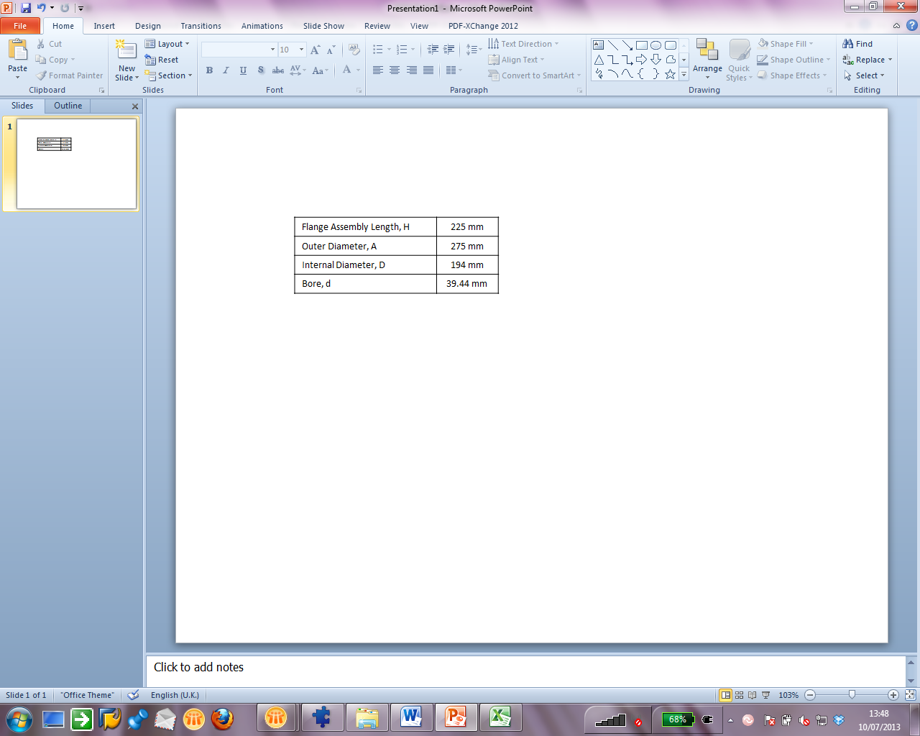C:\Users\gbjewil\Documents\Work 27.07.11\DP Engineering Tool\Drawings\FPD160.2-Layout1.wmfC:\Users\gbjewil\Documents\Work 27.07.11\DP Engineering Tool\Drawings\FPD150.1-Layout1.wmf